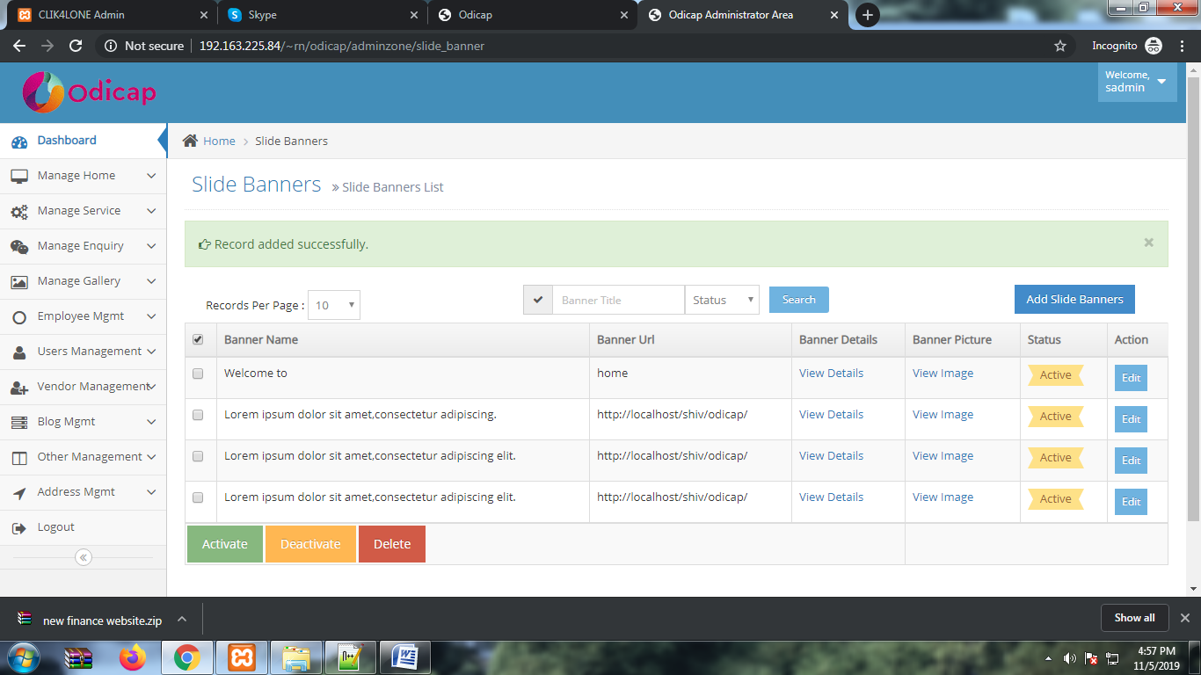
In banner view list mulyi check box not working and change the placeholder value in banner section

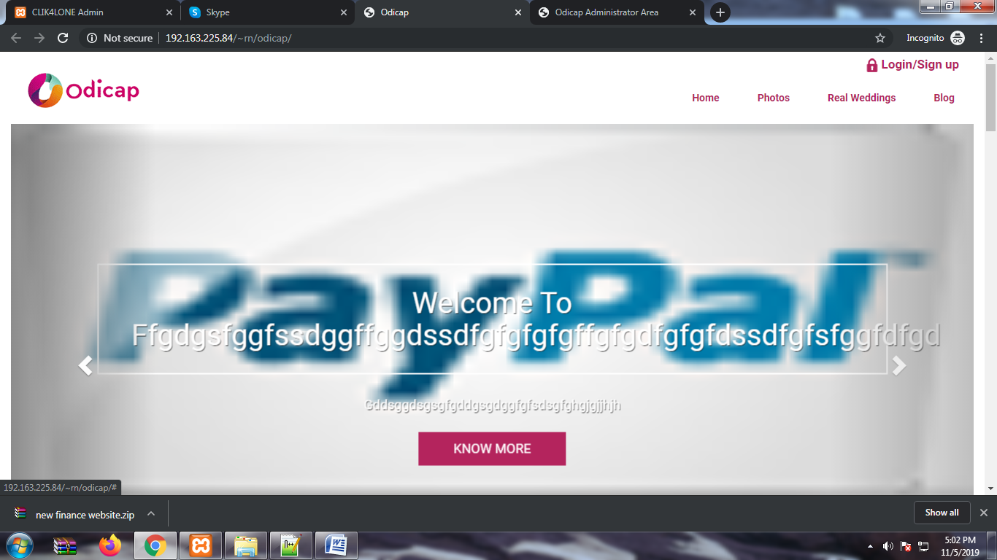
Add character limit

If all the field required ad 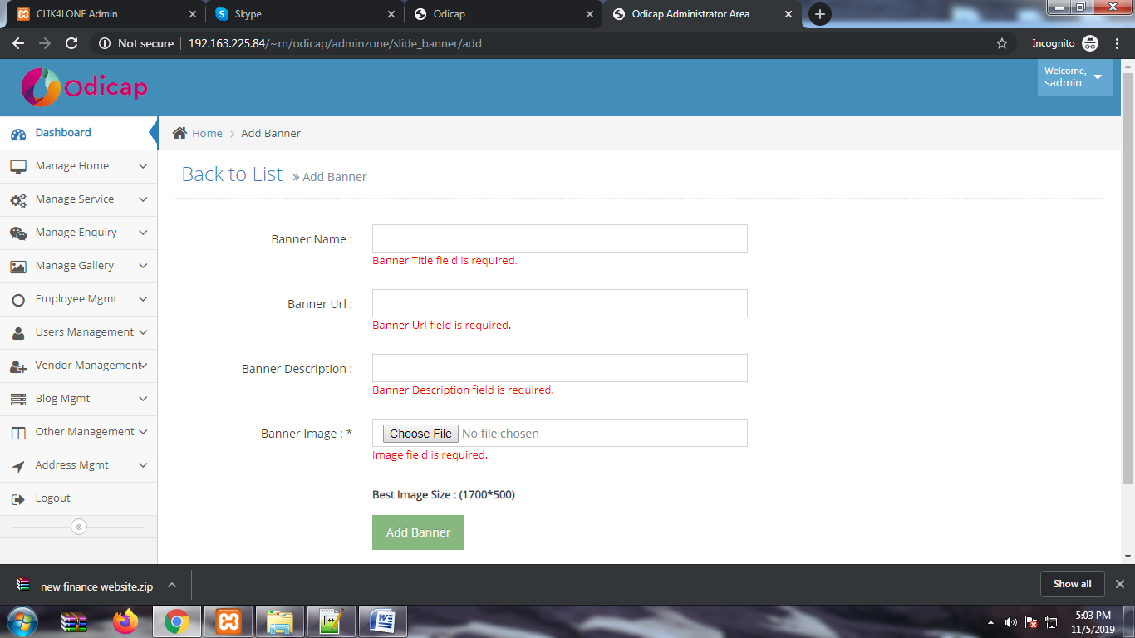
If all the field required add * in each section

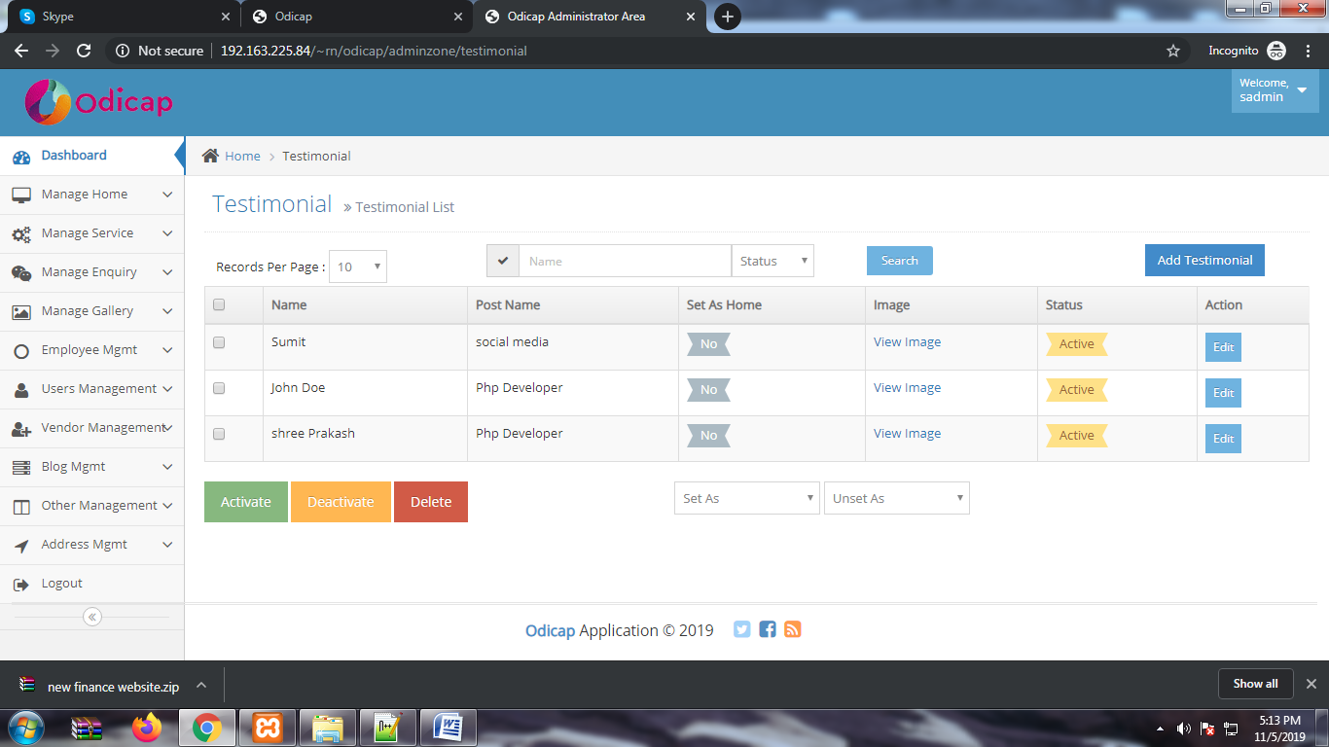
In testimonial section add detail section in in view page because in add section we also add description.and no need for set as home section.when we change in unset data is also visble in UI.

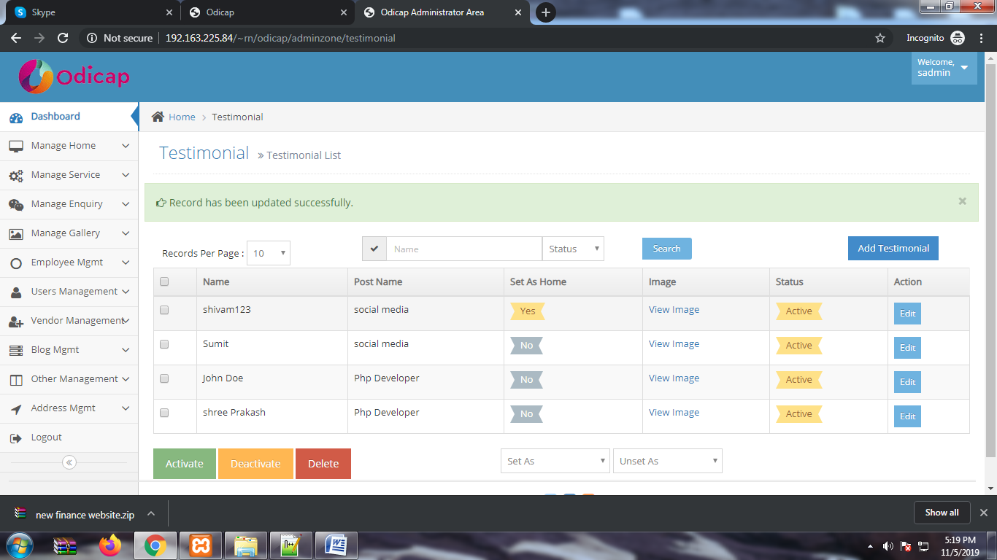
Name take a numeric value in testimonial section.

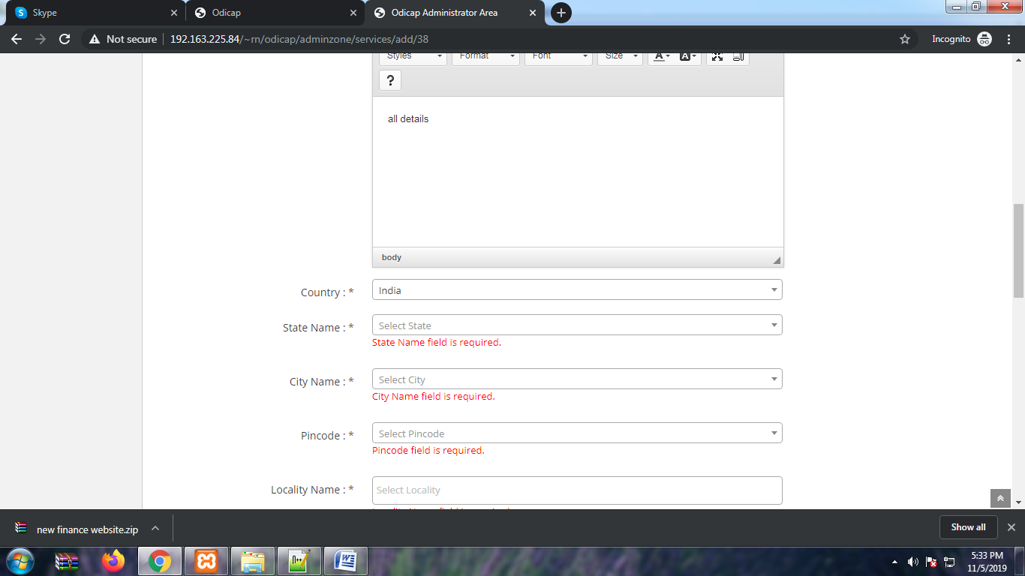
Are set the dropdown in country state city name and pincode but in dropdown will be empty. In add service page

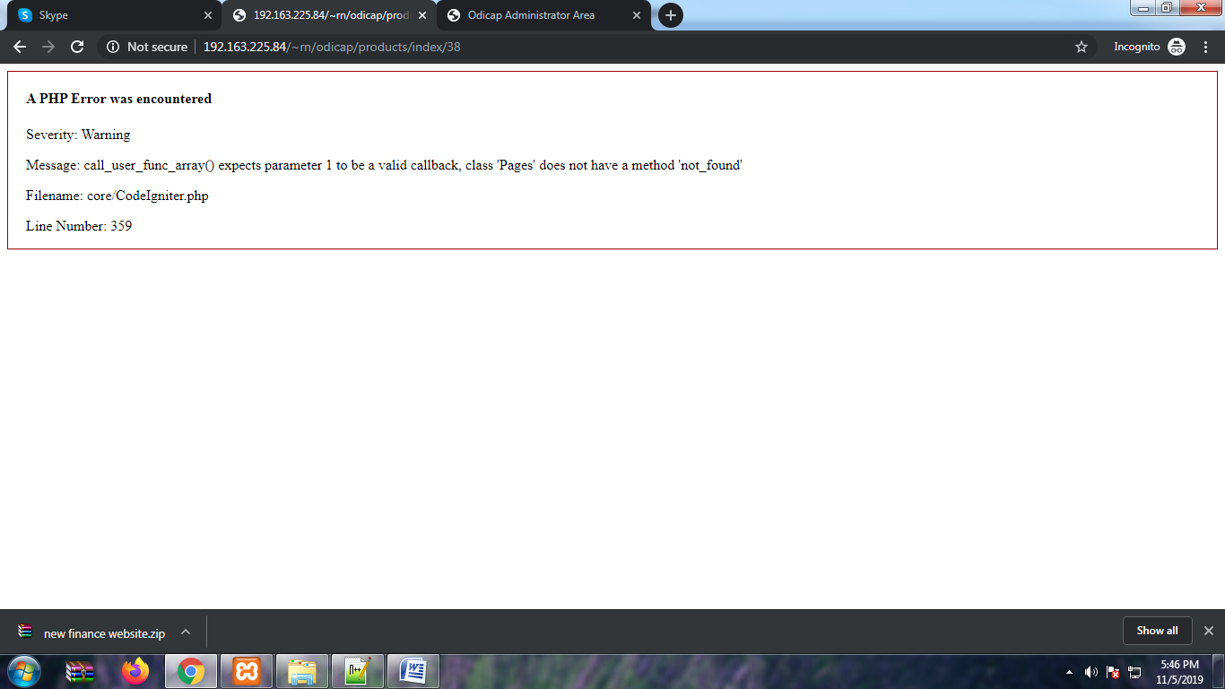
In fronend if we selected any service or clicl to any service shopwing this php error.

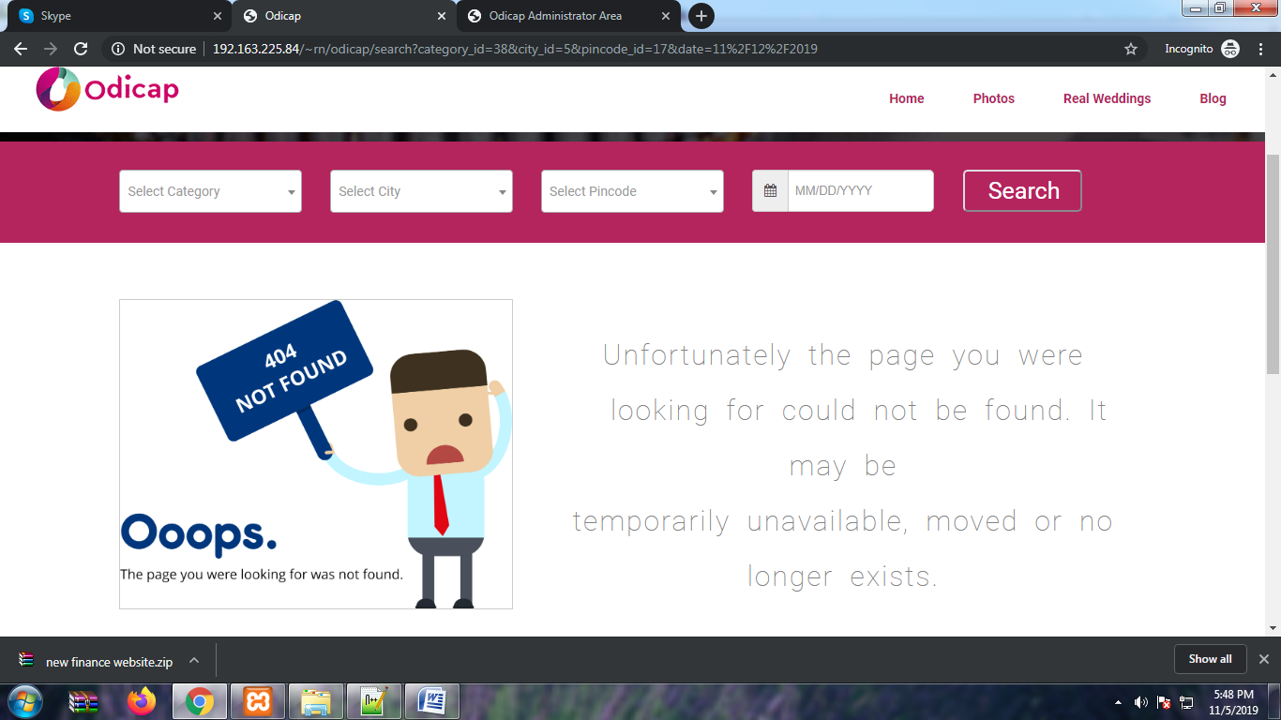
Remove this page and add the more option to the client.

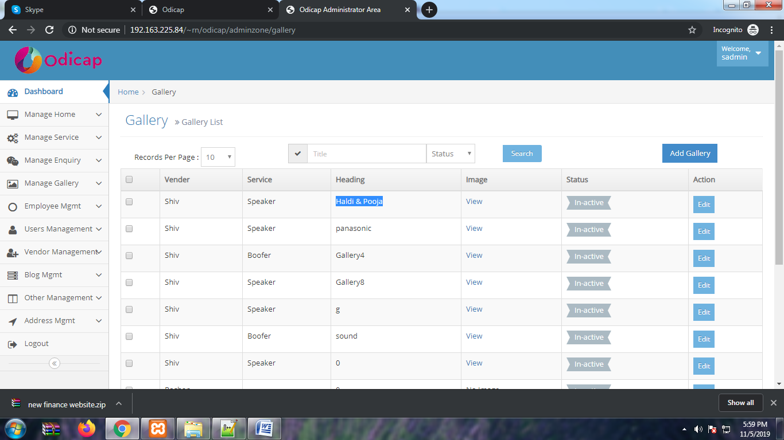
If vender and service section needed put as the same otherwise remove it because client add only heading and image option.

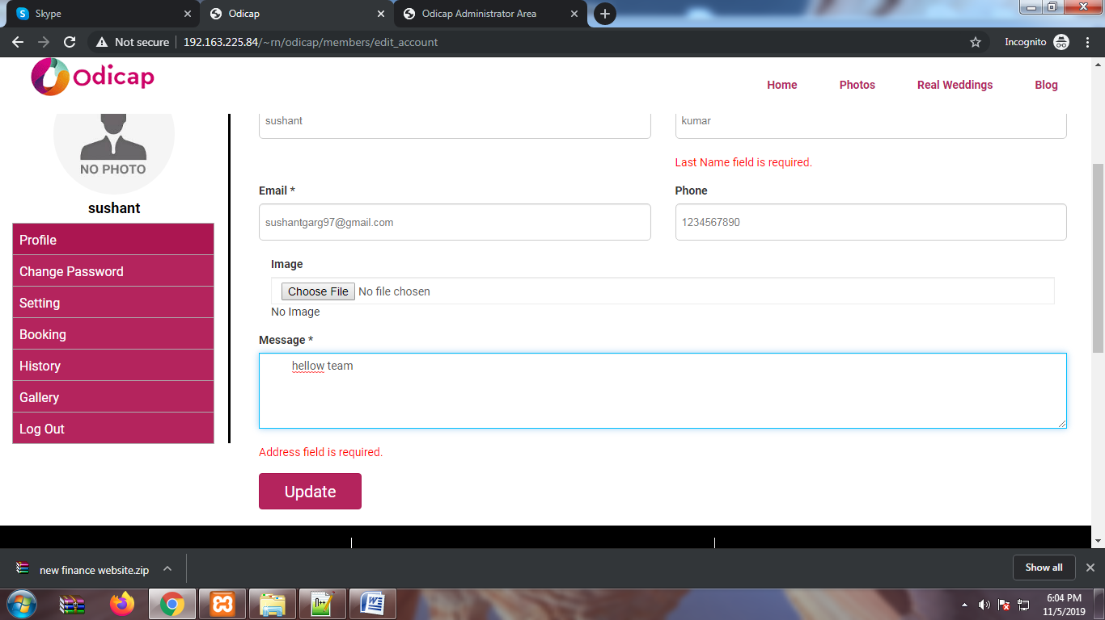
Validation messege showing address is required there in no address section. In user login

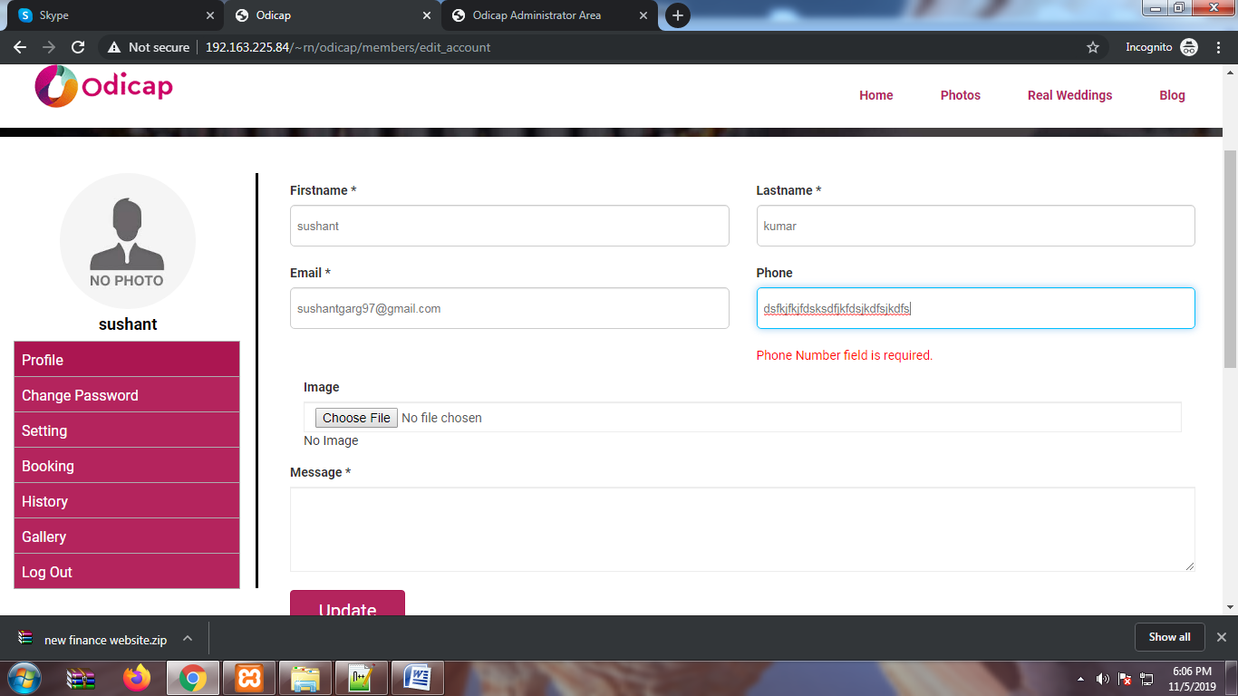
Phone number also take charcter.

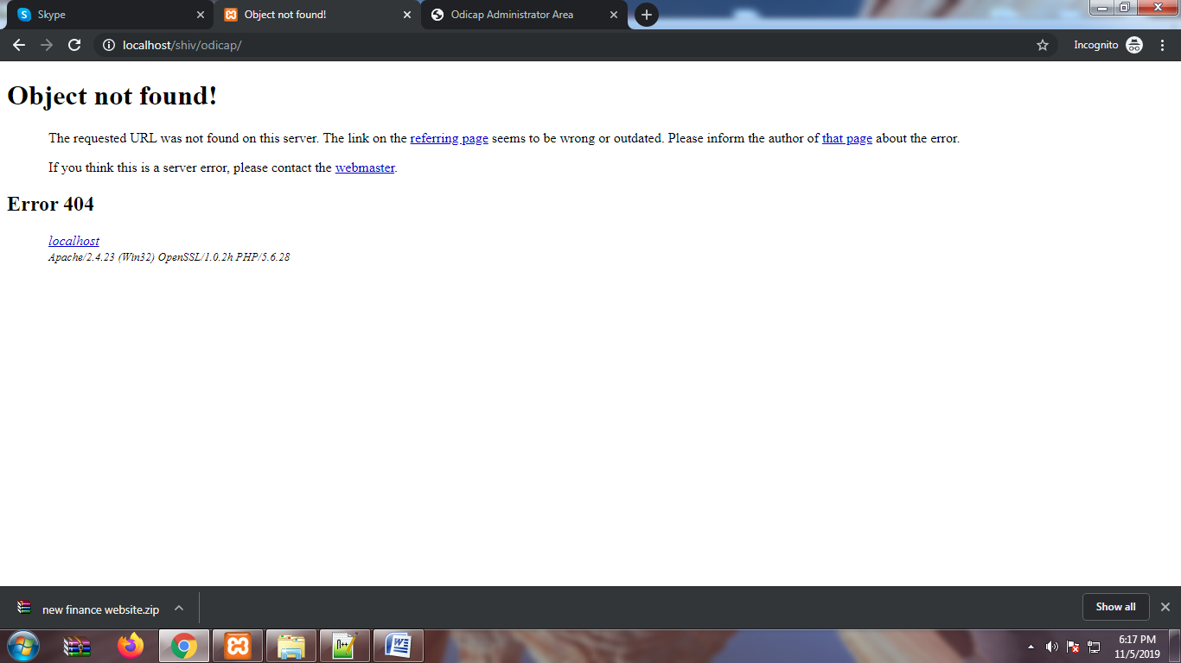
Home banner know more button redirect in this page.

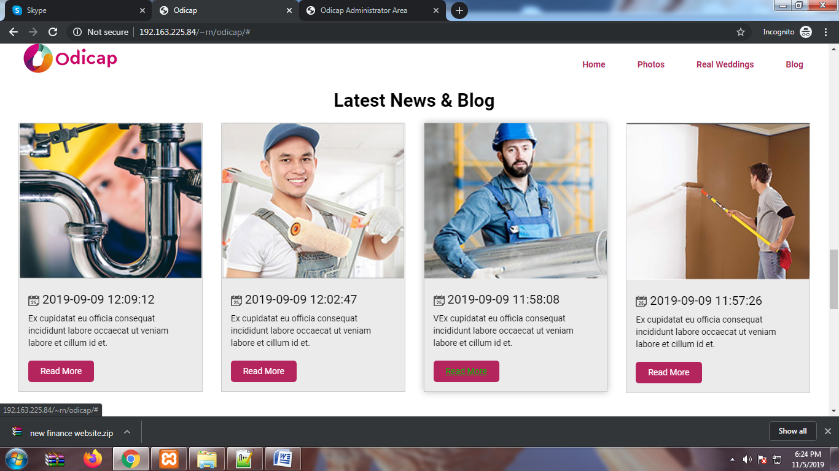
Read more button is not responding
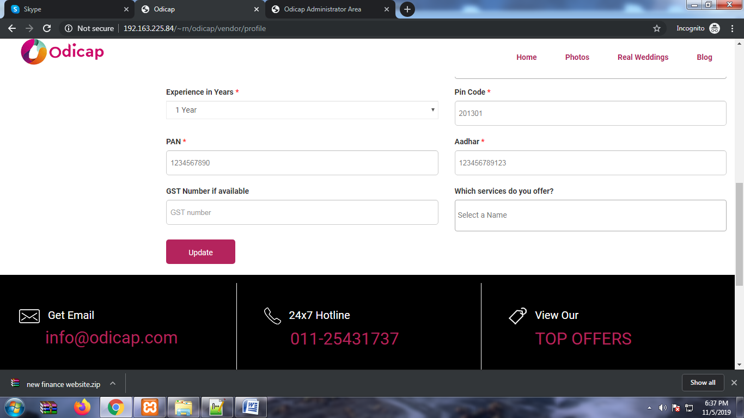
After fill all the mentor details vender cant update his details after clicks many times in update button data not be submitted in Vender registration
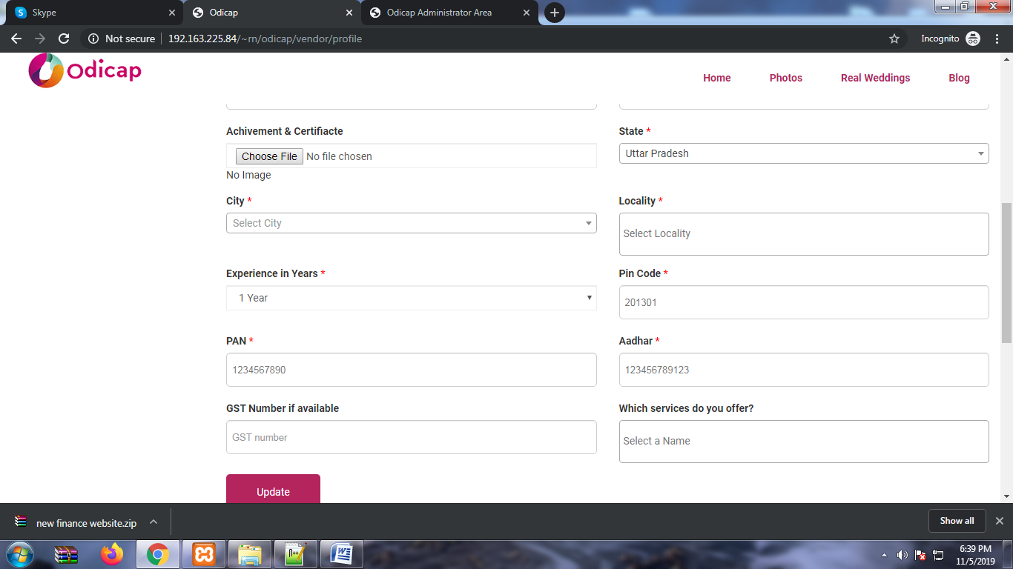
There is no city in dropdown list.

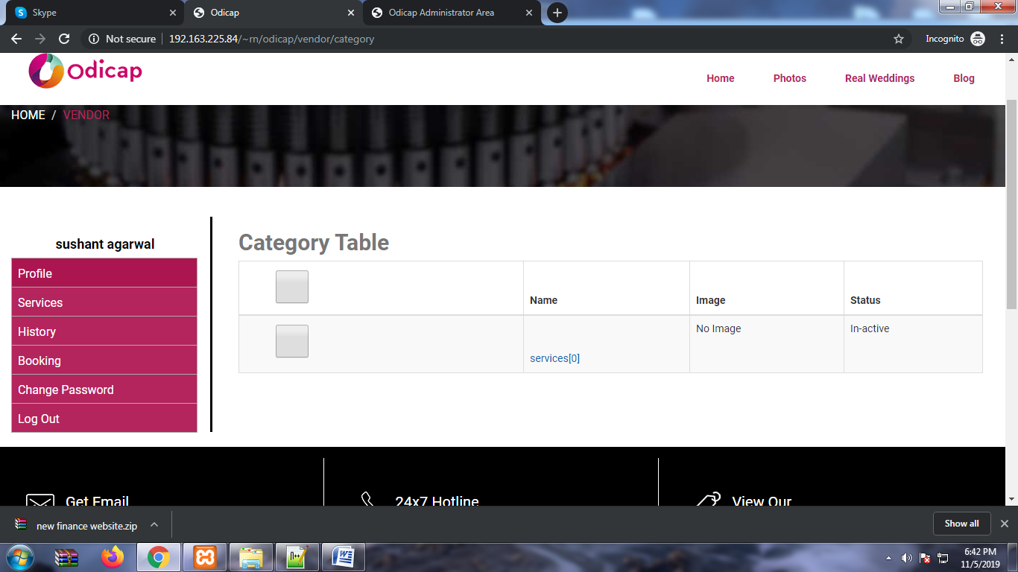
No use of category table in vender account

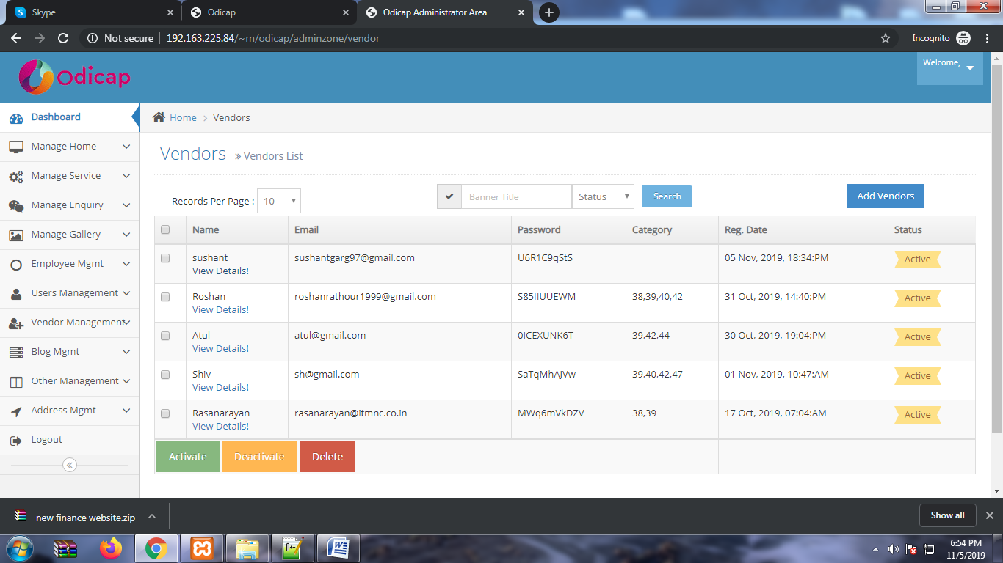
Banner title in search box remove plaveholder.

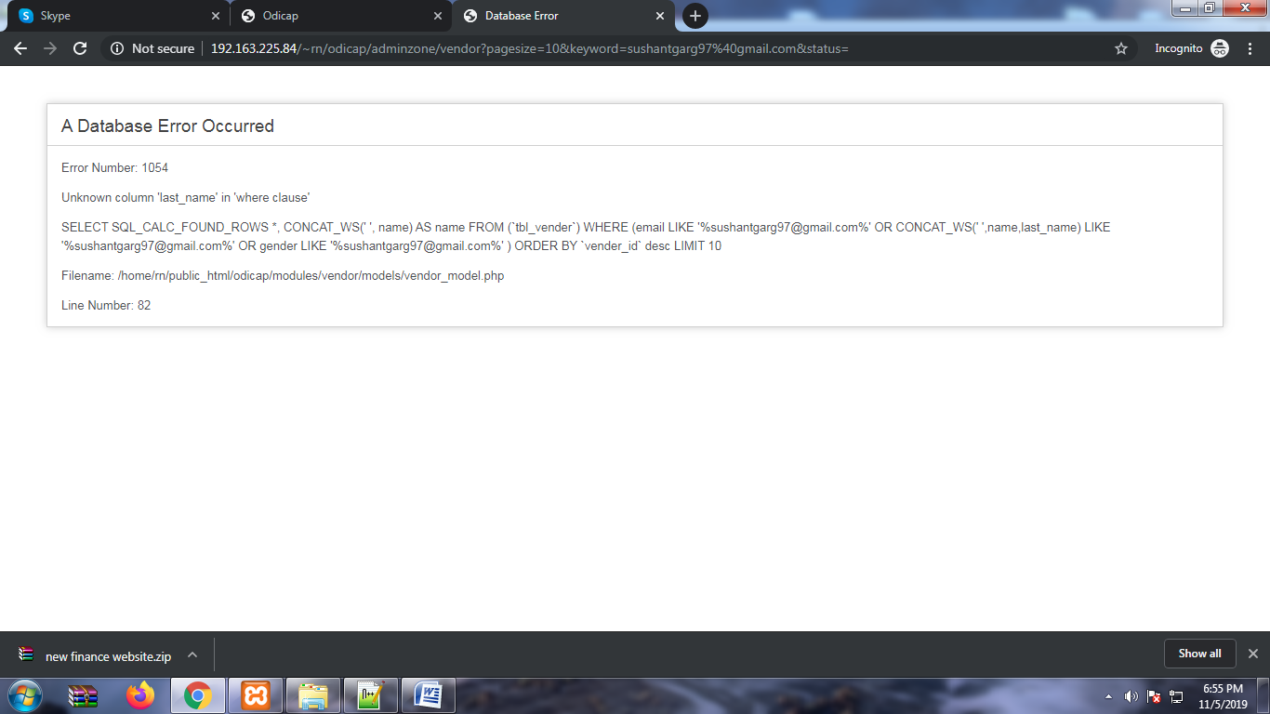
Database error in vender lsit if we searched by email id or name

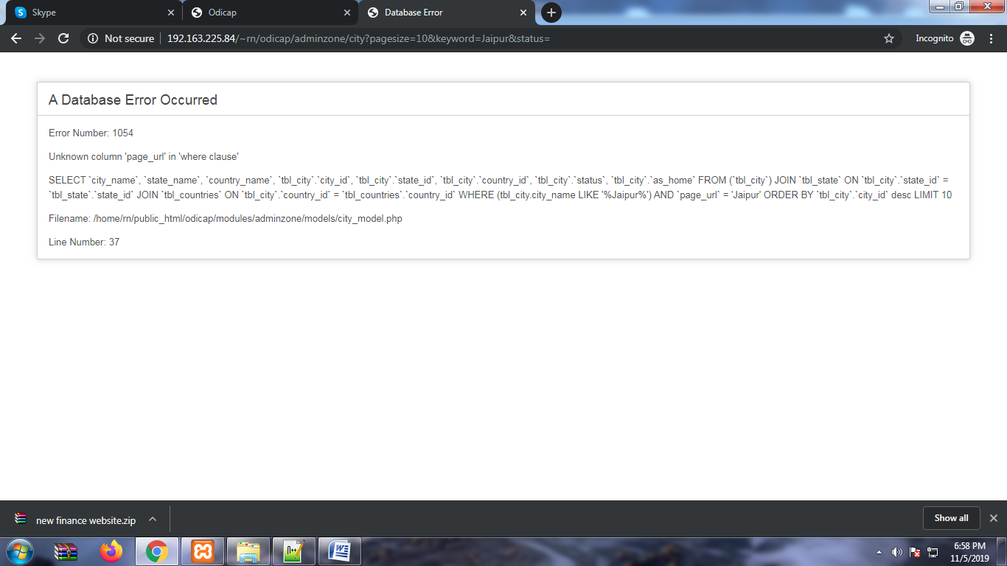
City list if we serarched by city name ,state ,country

